Part 1:

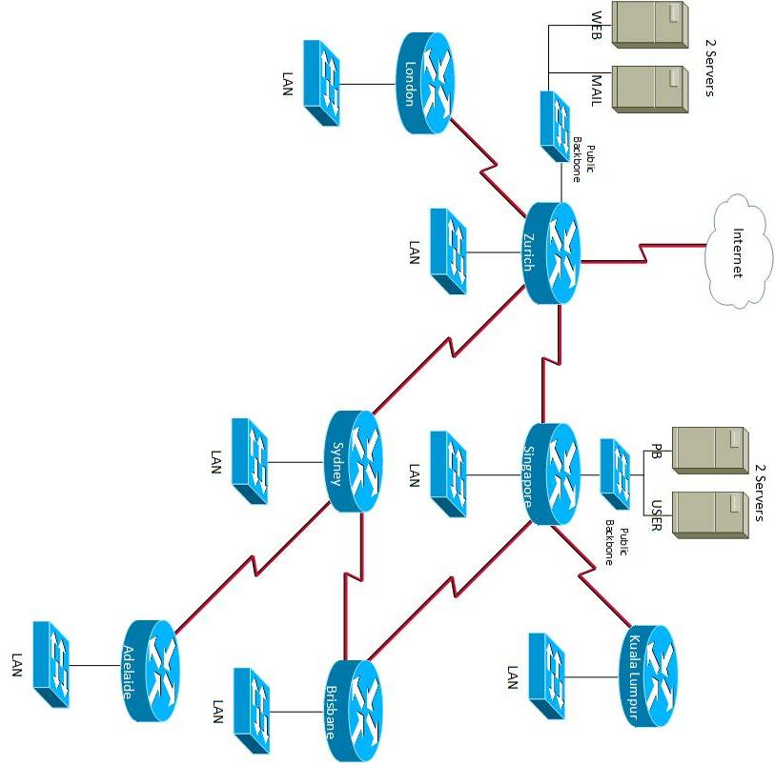

Part 2:

Host Summary Table:

|  |  |  |
| --- | --- | --- |
| Number of Hosts Per Subnet | Subnet Size | Number of Host Bits Required |
| 1500 | 4096 | 12 |
| 900 | 2048 | 11 |
| 450 | 1024 | 10 |
| 400 | 1024 | 10 |
| 240 | 512 | 9 |
| 120 | 256 | 8 |
| 60 | 128 | 7 |
| 5 | 8 | 3 |
| 5 | 8 | 3 |
| 2 | 4 | 2 |
| 2 | 4 | 2 |
| 2 | 4 | 2 |
| 2 | 4 | 2 |
| 2 | 4 | 2 |
| 2 | 4 | 2 |
| 2 | 4 | 2 |

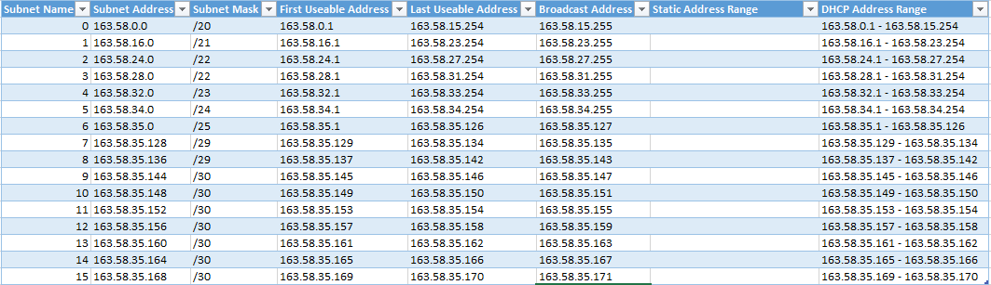Subnets:

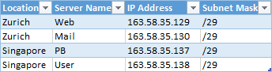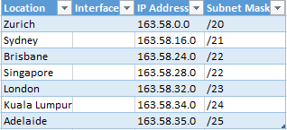Router Interfaces: Servers:

Part 3:

**Executive Summary:**

**Purpose:**

An online gaming company wants their corporate network assessed and redesigned.

**Scope:**

The current network topology will be redrawn using Visio and then the entire network will be subnetted including addresses for expansion. New hardware will be researched for the Singapore and Kuala Lumpur networks and placed into a weighted decision matrix for help with selection. The entire network’s security will then be looked at and Access Control Lists (ACLs) will be applied to filter traffic.

**Weighted Decision Matrix:**

Routers:

Switches:



Workstations:



**Budget:**

Chosen hardware:

Router - NetGear FVS336G Dual WAN Gigabit SSL VPN Firewall Router - $289 each

Switch - Cisco SG 300-52 52-port Gigabit Managed S - $1,049 each

Workstation - HP Z240 (Custom) - $1,492 each

Total hardware cost:

Singapore:

* Router x 1 = $289
* Switch x 8 = $8,392
* Workstation x 400 = 400 * $1,492

Singapore Total = $605,481

Kuala Lumpur:

* Router x 1 = $289
* Switch x 3 = $3,147
* Workstation x 120 = 120 * $1,492

Kuala Lumpur Total = $182,476

Grand Total = $787,957